An Unlikely Lent:
Extraordinary People of the Easter Story

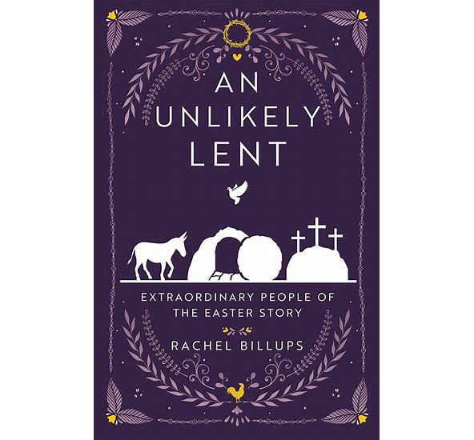
An Unlikely Lent

Notice the unexpected in Easter. The crucifixion and resurrection of Jesus are at the heart of the story of Easter. But the resurrection was not witnessed in isolation; it unfolded before a crowd. What might the stories of those women and men teach us today? How will they help us step into the story of Easter? Here, we can see what has been overlooked, not just in the grand moments but in the in-between: the silence, the side characters, and the questions. Gain new insight from the crowd on the themes of: -Devotion -Opposition -Freedom -Courage -Companionship -Alliances By seeing the Easter story through their eyes, we may discover that the resurrection is not just a past event, but an invitation into something new, unexpected, and unlikely. Walk through this season with eyes wide open, ready to see where God is moving, even in the margins. Since the cross is not the end of the story, embrace every unlikely moment along the way.
  David Garrett Rev. Beth Labella Foster | Tuesdays,  Starting February 24th  6:30 – 8:30 PM  In person  Contact:  Dlgarrett4rb@gmail.com  302-515-5290

