Christianity and World Religions

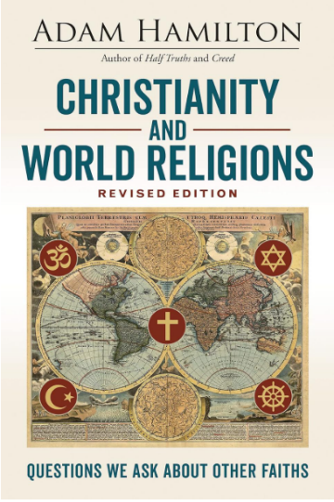
Pastor and best-selling author Adam Hamilton returns to one of his most popular topics, Christianity and world religions. This book explores four major world religions—Hinduism, Buddhism, Islam, and Judaism—and compares the beliefs of each with those of Christianity. He deals openly and honestly with questions people ask about other religions, such as:
- Why are there so many different religions?
- How should Christians view other religions?
- How is God at work in other religions?
- What is the fate of those who earnestly pursue God through other religions?
In examining these major world religions and the beliefs of their followers, Hamilton urges Christians to build bridges with others so that we might grow in our faith, seek peace in our world, love our neighbors, and find positive ways to share the gospel.
  Mike & Robin Duer | Wednesdays,  March 4th – April 15th  (no meeting April 87^{th)}  7:00 – 8:30 PM  In person, Starnes Room  Contact:  Beachrobin12@aol.com mike41024@aol.com  Robin: 302-524-4716  Mike: 703-980-3743

