

Class purpose involves self-improvement.
Men who focus on their personal development are better able to be of service and make a positive impact for others. The purpose of our group is to create a world where men take individual and collective responsibility for our shared future by supporting each other on a path of emotional maturity, spiritual awareness, and deepening community involvement. Self-awareness, increased compassion, emotional intelligence, accountability, and self-purpose are all key to our mission.
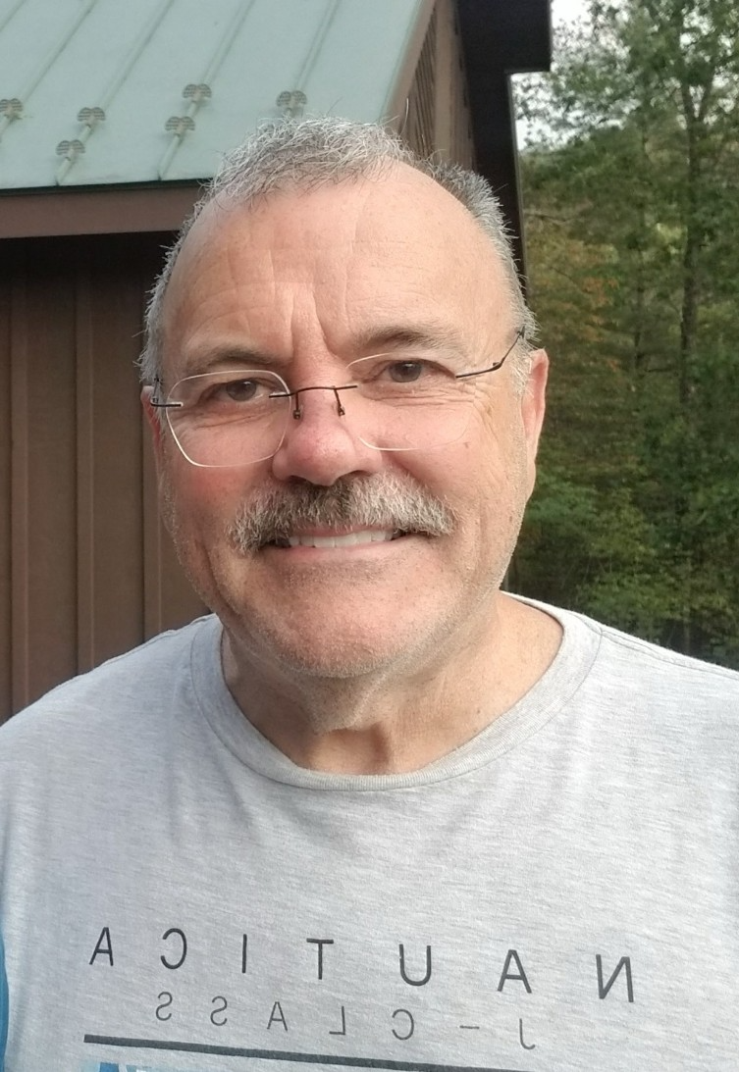  Shawn McHush | In person  1st & 3rd Wednesdays  Ongoing  6:30 - 9:00PM  Contact:  Smchugh301e@gmail.com  240-285-7183

