Meditation: w/Spiritual Aging

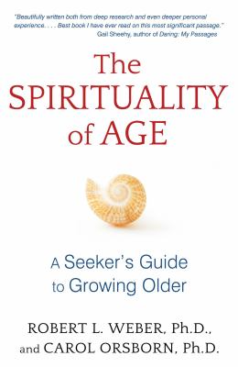
The Spirituality of Age

“These days we often hear the word spirituality. The spiritual search is a vital and continuous area of personal reflection for these authors. They encourage each of us to define the meaning of that word for ourselves. This book opens the door for all of us to explore our own growth, insights, inner peace, and continued learning that is calling to us as we age”
(Connie Goldman, Author of Who Am I Now that I’m Not Who I Was?)

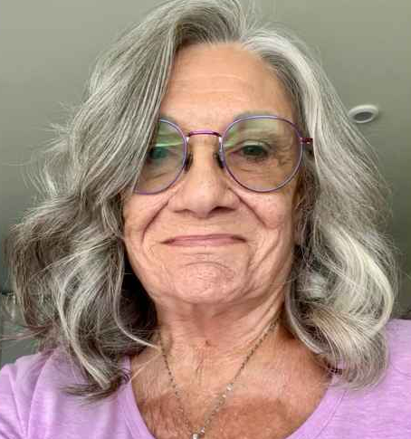  Susan Love | Thursdays,  Starting February 26  For 10 weeks  10:00 – 11:30 AM  In person  Contact:  Slove777@icloud.com  202-262-5441

