How to Know a Person

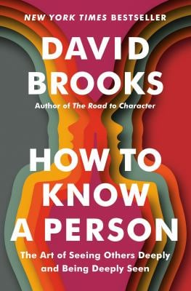
This book nurtures your spiritual life by improving human connection, seeing others deeply and be seen in return. Drawing from psychology, neuroscience, and other fields, the book offers actionable advice on conversation, attention, and empathy to build stronger relationships, moving beyond abstract ideas of "community" to concrete social skills like good listening, asking the right questions, and sharing vulnerability. It is for anyone seeking deeper connection and understanding in their personal and professional lives.
Key themes and takeaways:
- The art of attention
- Beyond small talk
- Seeing the whole person
- The power of vulnerability
- A practical, hopeful approach
- A remedy for loneliness

  Todd Popham | Thursdays,  February 26th – April 2nd  7:00 – 8:30 PM  In person  At:  18380 Alpine Loop  Lewes, DE  Contact:  Todd Popham  toddpopham@gmail.com  443-517-3150

