Brothers in Christ

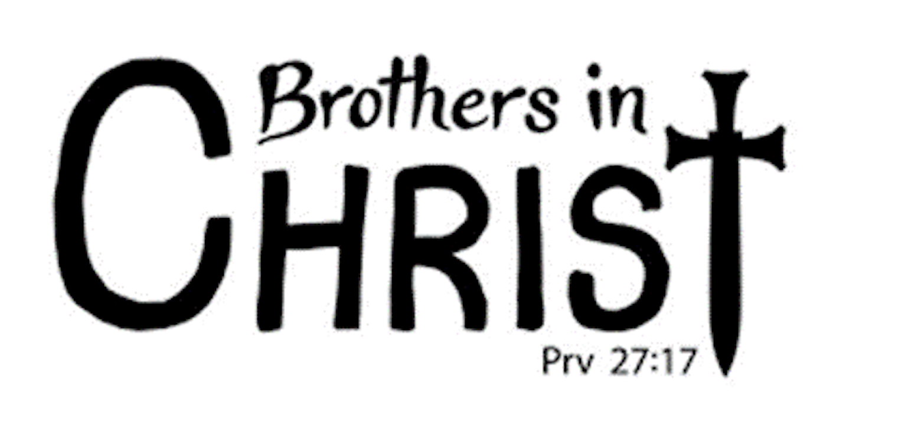
Epworth Men’s Ministry

The Purpose of this group is to provide a new direction for men’s ministry at Epworth, enabling men to build relationships while they explore their faith and embrace community. We will include Book studies, Speakers, Accountability Groups, Leadership Development, & Community Service.

Todd Popham | Bi-weekly, Wednesdays  9:00 – 10:00 AM  @Panera  Contact:  toddpopham@gmail.com  443-517-3150

